AWS: SNS (Email)
STEP 1-
Go to you SNS dashboard and click on create topic
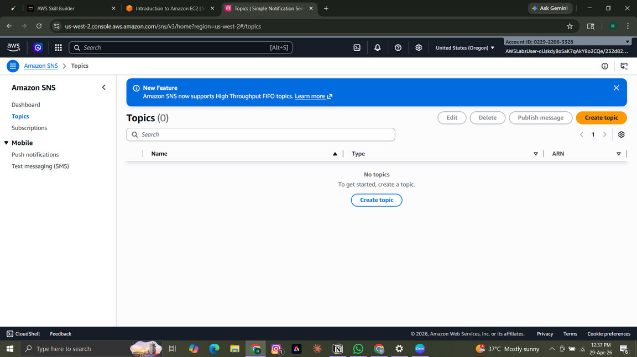

STEP 2-
Click on the topic type you want. FIFO (first in first out) sends the message to people in sequential order or in que order whereas stand sends message to the one who are available. Then give your topic a name, After that it is optional to add display name. display name the name which the user can see when they receive the email.
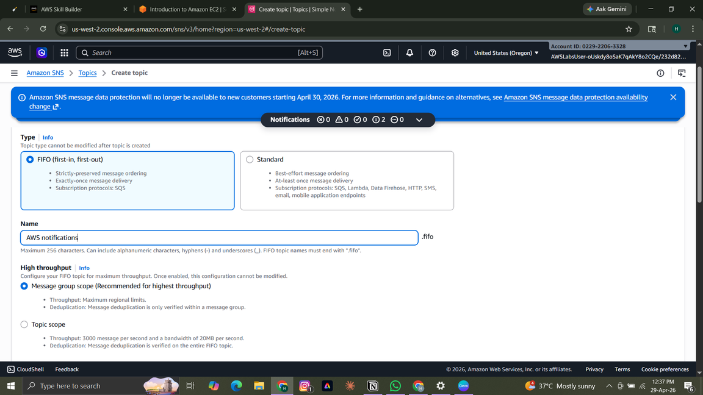
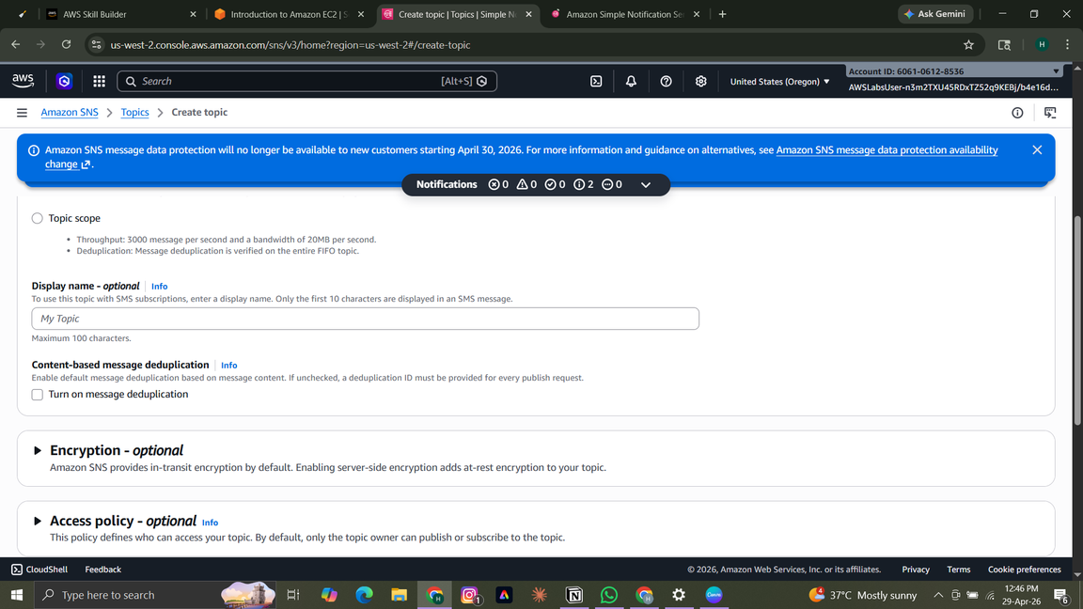
STEP 3-
After the topic is created click on add subscriptions. under protocol select the option through which we have to send the notification. For email we wll choose email as protocol. Then enter the email of the person. Click on create subscription. After that wait for the user to verify. If the user does not verify you can not send email to them. Go back to the topic dashboard and you can create more subscriptions if you want.
STEP 4-
Click on subscriptions you want to sent the email to and click on publish. You can add the subject of the email if you want ,then scroll down ,write the body of the email and then publish it. The subscriptions you had selected will receive the email which you published.

